PIDs
Overseeing group planning implementation activities for each center
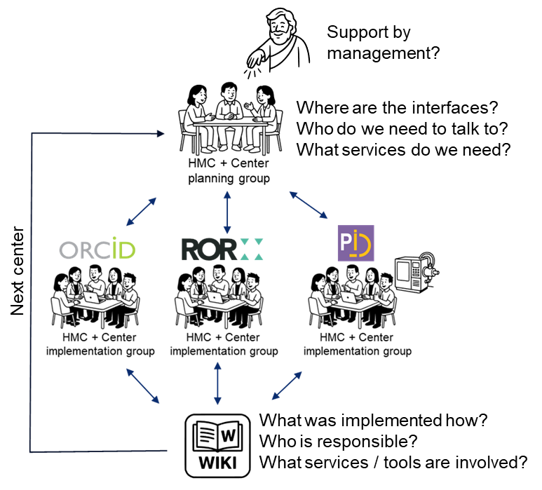

Use Case 1: GEOMAR
Working group:
- HMC: Andrea Pörsch, Emanuel Söding
- GEOMAR: Hela Mehrtens, Klaus Getzlaff
What is the current status in capturing PIDs?
* which PIDs are already systematically captured? Describe details in PID sub-pages.
* who is responsible for capturing them?
* what tools are used to capture them, where are they captured? Links to tools if possible.
* are there already established workflows describing these processes? Describe details in PID sub-pages.
What tools do we need or are involved?
What are the next steps?

Use Case 2: Geoforschungszentrum Potsdam (GFZ)
Working group:
- HMC: Andrea Pörsch, Emanuel Söding
- GFZ: Luise Ott, Thilo Paul-Stüve, Frederick Tilmann, Kirsten Elger (?)
What is the current status in capturing PIDs?
What tools do we need or are involved?
What are the next steps?

Use Case 3: Helmholtzzentrum für Umweltforschung (UFZ)
Working group:
- HMC: Andrea Pörsch, Emanuel Söding
- UFZ: Johann Wurz, Paul Remmler (unconfirmed)
What is the current status in capturing PIDs?
Who is responsible for ORCID?
What tools do we need or are involved?
What are the next steps?

Use Case 4: KIT
Working Group
- HMC: Andrea Pörsch, Emanuel Söding
- KIT: TBN
What is the current status in capturing PIDs?
What tools do we need or are involved?
What are the next steps?

Use Case 5: Hereon
Working Group
- HMC: Andrea Pörsch, Emanuel Söding
- Hereon: TBN
What is the current status in capturing PIDs?
What tools do we need or are involved?
What are the next steps?

Use Case 6: AWI
Working Group
- HMC: Andrea Pörsch, Emanuel Söding
- AWI: TBN
What is the current status in capturing PIDs?
What tools do we need or are involved?
What are the next steps?

Use Case 7: FZJ
Working Group
- HMC: Andrea Pörsch, Emanuel Söding
- FZJ: TBN
What is the current status in capturing PIDs?
What tools do we need or are involved?
What are the next steps?

